Editor’s note: My dear friend from Holland, Dr. Guus Flogel, makes the most extraordinary pop pop boats in the form of wooden Dutch shoes. Guus is a retired dentist and professor; and an active artist and experimenter. He has written a companion article about his experiments comparing different sizes of tubing and how many of turns of coil worked best which can be seen at https://goo.gl/K3keT3

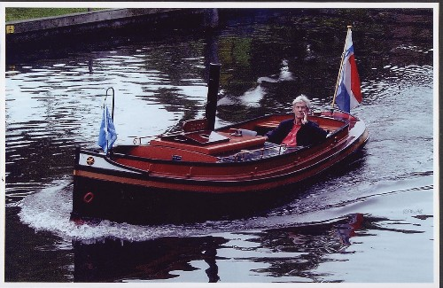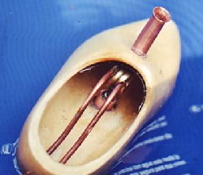

HOW TO BUILD A “STEAMSHOE”
WHY BUILD A ”STEAMSHOE”,

SELECTING THE HULL.

All my pop-pop boats nowadays are made from traditional wooden shoes. Why? Let me enumerate the advantages:

Firstly: Wooden-shoes are available in any size everywhere in the Netherlands. Many Dutchman still wear them. There are still more than 80 factories making them*.

Secondly: Wooden-shoes are cheap and the material is easy to work on

Thirdly: An important feature is the instep of the shoe, protecting the engine and the heat source (flame) against draught.

Fourhly: Wooden-shoe hulls are very sturdy compared with most light weight pop pop boats. Engines can easily exchanged without any risk of damage to the existing hull. I have exchanged the engine in my first hull for a newer design on four occasions. The boat still looks like new.

Fifthly: A disadvantage (?) of steam shoes is their weight, as shown by the figures of some examples**:
1: length 4” (12 cm.) weight about 100 grams
2: length 6.3” (16 cm) weight about 200 grams
3: length 7,5” (19 cm.) weight about 360 grams
4: length 9” (23 cm.) weight about 650 grams
5. length 1, 1/5” (30 cm.) weight about 820 grams

All examples given here are heavy compared with the usual light-weight pop-pop boats. But given that boat nr. 5 is running about
6 m / min. and nr. 3 in a good mood 8,5 m/min, then it is clear that the weight is not a major factor.

Sixthtly: I must confess, my personal preference is influenced by my emotional bond with wooden shoes. Besides tulips and windmills there nothing is so profoundly rooted in the Dutch middle class culture.

picture 1

SELECTING THE ENGINE

Although any kind of pop-pop engine can be mounted in a wooden shoe hull, my first choice is the coil engine, in spite of the fact that it is missing the audio-attraction of the pop-pop sound that diaphragm engines produce. Let me explain why; when I was a little boy, I was given a pop pop boat by one of my aunts. I fell in love almost immediately. (With the boat, that is.) The passionate clicking sound, the romantic flickering of that little candle in the dimmed light of the bathroom, this all exited me and tickled my imagination. But like most love affairs, the period of euphoria did not last. The next day I eagerly lit a new candle, but after a few minutes the pop pop sound faded away slowly and then suddenly stopped. In spite of all my efforts, the refusal was relentless. Dead! I was inconsolable.

70 years later, impressed by the pop pop site of my dear friend Slater Harrison *, I decided to build such a pop-pop boat myself. The first vessel was followed by at least twelve others. I became passionate. But now and then I was confronted with a burn-out. Other fans ensured me that such a disaster - though a well-known phenomenon, could easily be prevented, simply by blowing the candle. Paying close attention one can hear the warning sign: the pop pop sound fades away. That information proved correct, but soon I found out that, if the warning is discovered a split moment too late, the game is over. I decided to look for an engine that would never, never could lead to a burn-out. Reading about the subject, my attention was drawn to coil engines. They did not get much attention in the literature but were described as practically indestructible. In spite of the fact that they lack the attractive pop-pop sound, my choice was made.

Other considerations:
-Some people believe that coil engines are not as powerful as diaphragm engines. Others believe coil engines are stronger. There are so many different types of engines in both groups, that objective comparison is difficult. Who cares? Just as in traffic, reliability is often more important than top speed.

-Depending on the material used, the making of coil engines is relatively easy, at least technically. They are in fact nothing more than a bent piece of pipe. It is still disputable from what material the best performance can be expected. For practical reasons I use copper pipe.

MAKING A COIL ENGINE

Small size copper tubing is available in many diameters in hobby shops selling parts for miniature trains, cars etc. They sell it in length of 100 cm. (40 in). For small vessels piping with an O.D. of 3 or 4 mm (approx 1/8 or 5/32 in) is the right choice. Their I.D. is 2-3 mm. Recently however, we have learned that tubes with an I.D. of about 4 mm perform considerably better. Of course these engines need much more space. Steamshoes suited for engines of this size have to be larger than 19 cm (7,5” ). They are sold everywhere in the Netherlands. From abroad it is easy to order them.**
Besides hobby-shops, also automobile-parts chains and plumber subcontractors sell copper tubing with an I.D. of 4mm, but their external diameter is 6 mm. instead of 5 mm. In spite of the thicker walls these pipes are, at least in my hands, easier to handle. I could not confirm it until now, but I have the feeling that engines of these tubing are not performing as well as the 5 mm O.D. pipes. The pipes with the thinner walls are much more difficult to handle. The best method is to fill them with silver-sand and closing both sides before starting the annealing procedure. This is the best way to prevent kinking.
When making an engine of 3 or 4 mm tubing, a coil diameter of about 10 mm and 3 or 4 turns, a length of 50 cm (20 in) will be sufficient. For engines of the second group, (O.D. tube about 5 or 6 mm, I.D. coil about ½ inch and 5 or more turns), first calculate the length of the pipe you need before cutting a piece of it. It makes sense to add a least 10 % .
The length of the pipes measured from coil to nozzles is rather critical. So far, we have not been able to establish the margins between too short and too long . For engines of the 3 and 4 mm O.D. group, reckon with a length of 12-15 cm. For the second group about 20 cm will be O.K. Also, it is fun to experiment with the coil diameter. For the second group the diameter and the number of turns is limited by the space within the wooden shoe.
In this instruction only the making of a coil for the first group is described. The technique for the second group is principally the same.
First method:
To make an engine you need a 50 cm (20 in long tube. This may seem exaggerated but as I shall explain later this length is preferable. Do not overestimate your skill. Buy more material than you think you need. What can go wrong will go wrong. Making a coil seems simple but it takes a lot of experience to build one that really looks perfect and performs well.
The first thing you have to do is to anneal the copper. Annealing is a kind of heat treatment that makes this material softer. This is important because bending a hard tube will cause kinks (which block or restrict the tube) rather than smooth bends. Strangely, copper is softened in exactly the way steel is hardened, by heating to red hot and quickly quenching in water. As copper is worked (bend, for instance) it once more starts to harden and must be annealed again.
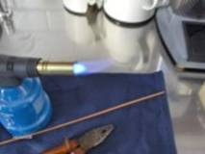
picture 2
The annealing procedure is as follows: hold the tube with a pair of pliers to prevent burning your hands. Heat with the help of a propane torch, starting in the middle of the tube over a distance of about 7 cm. (3 inches) until cherry red. Propane torches are available wherever plumbing supplies are sold. (picture 1).
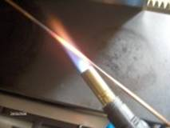
picture 3
After lighting, turn the gas valve wide open. In the middle of the flame you see now a bright, light blue cone. Keep the torch under a sharp angle with the tube, in such a way that the top of the cone is near the tube (picture 3). As the heated part of the tube becomes cherry red, plunge it in a bath of cold water. If by accident you crush the end of the tube with the pincers, don’t worry. This is why the tube had to be somewhat oversized.
It is better to anneal too many times than too few. This prevents the risk of kinking and squeezing the tubes, which can impede the water flow. This jeopardizes the performance of the engine. Keep in mind that once the material is kinked a bit, it is impossible to make it undone! Take a deep breath and pick a new tube.
Then take a round bar or pipe of 12 mm (1/2 in) diameter and 100 mm (4 in) long and clamp it firmly in a bench vice. Now carefully adapt the annealed part of the tube around the cylinder. Press one side of the tube firmly against the cylinder and turn the free end. Go on adapting until you feel the slightest resistance of the material. Stop and anneal again. To complete the first turn this has to be repeated two more times generally. The second and the third turn can be executed in the same way.
After the coil is finished, the rest of the tube is shaped. Rather then by means of a description, this is demonstrated with the help of picture no 4. There are only two instructions to be given: 1: do not forget to anneal during the shaping process and 2: avoid sharp angles.

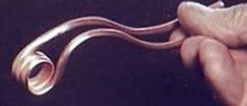
picture 4
Second (and better) method:
However, since the making of a coil as described can simply be done with the help of a short bar and a vice bench, quite some skill and experience is required and even then the risk of kinking is not avoidable. A easier and safer method is to make use of a device as described by Richard Brown.* Since you will certainly make more than one engine, it is worth the effort to make such a tool.
Take a wooden block and drill with a spade bit a hole in it of exactly the same diameter (12 mm, 1/2”) as the bar used in the first method: a round bar or pipe of 12 mm (1/2 ”) diameter and a 100 mm (4 in) long.
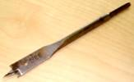
picture 5

With the help of this spade bit, the pipe should fit snuggly and be stable.
Besides this pipe the block holds 2 or 3 screws to keep one end of the copper tube straight in line. The screw situated nearest to the pipe has to prevent the tube from bending in this region.
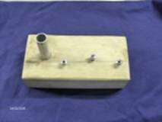
picture 6
Is your device ready? Anneal the tube approx. in the middle, and place it between the screws in the bloc.
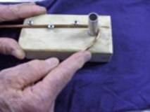
picture 7
Now bend the free end carefully around the cylinder by pulling.
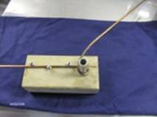
picture 8
Stop immediately at the moment you feel the slightest increase of resistance. Repeat the annealing procedure. Don’t be misled by the assumption that feeling this device should require fewer annealing procedures than needed for method 1.
After the coil is completed, bend the tubes until the engine fits properly in the hull of your boat.( See chapter “mounting the engine” ). This is done by hand (see above). It is important to avoid sharp angles to ensure minimal resistance of the water flow in the tube.
Not quite necessary but attractive is annealing the ready engine once again and quench it in pure alcohol. This is not dangerous! The result is surprising. In a few seconds the corrosion of the material will disappear and the copper will regain its original soft shining appearance.
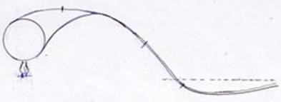
picture 9

This drawing shows: 1/ the coil, 2/ the relation of the flame to the coil, and 3/ the configuration of the tubes behind the coil and the stern and 4/ the inclination of the end of the tubes to the water level ( = ------------- ).

SELECTING THE HEAT SOURCE

The most commonly used heat sources for pop-pop boats are candles, alcohol burners or trays with burning gel. Most diaphragm engines are heated by a candle. For these engines, candles are safer than alcohol burners, which almost unavoidable deliver more heat than diaphragm engines can bear, which easily can lead to a burnout. For coil engines however, alcohol burners are preferable because they need more heat to run properly than a candle can deliver. Alcohol burners are clean (no soot!), can produce any amount of heat a coil engine needs and they burn pretty constantly. The adjustment of the heat requires some experience. The latter is important. The thrust of the engine increases with the amount of heat, but above a certain limit no longer perform properly and will eventually stop. After some time one learns to establish the critical margin.
Another heat source is a tray filled with burning gel. But its heat is not adjustable at all and for this reason not suited for our purpose. In general, the alcohol burner answers our requirements best. But before discussing the burner design, it is necessary to spend some words on the hull of the steams-hoe itself.

WORKING ON THE HULL

In the past I preferred the cheapest, unpainted wooden shoes. But the unpainted material is rather porous and consequently vulnerable to dirt. Therefore, before working up the shoes, I used to varnish them a few times. Dutch wooden-shoemakers deliver varnished shoes, but these are always decorated. Not to everybody’s liking. Recently I found a manufacturer who is willing to export shoes to any country. (1 pair or 100, it doesn’t matter) He is also willing to deliver them varnished but without decorations. That will save you a lot of time because after each layer of varnish you have to wait at least 1 day before you can apply the next layer. There are a number of different models. The real thing, the “working shoe” has a blunt nose. The more sophisticated tourist version has a slightly sharpened nose and a more elegant look. The latter is my favourite. How to order them, see **.

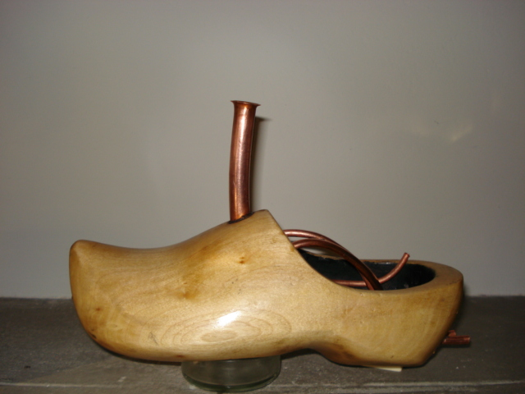
Picture 10

The first thing we have to do now is to drill an opening for the chimney. Chimneys can be made from different materials. The design depends on your personal preference. You can opt for a historical design (look for pictures in magazines of old steamers) or a freeer design. I like a long, light bended copper chimney with a trumpet-like top. Any design is acceptable provided the exhaust of heat is quaranteed. A plumber’s supply store will help you find a suitable piece of pipe.

As a rule the chimney must be placed in the middle of the hull, right above the coil of the engine, about ½” (12.7 mm) in front of the border of the instep.
Coil engines need a lot of heat to perform well. Alcohol addicts is what they are! This makes distinct precautions necessary: a generously wide chimney and an adequate heat shield inside the roof of the instep.
The place of the chimney has to be determined with the utmost care, because the transversal balance of the vessel can be easily disturbed by it. The right place is found by fixing the chimney provisionally on the roof of the inset, for instance with the help of poster buddies. Now let the shoe float freely in a basin of water. The chimney can be moved now from left to right until the equilibrium is found. Next, draw coordinates around the clay for the centre of the hole. (picture11)

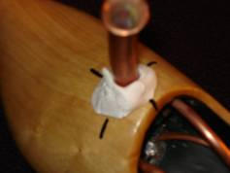 picture 11

The chimney and the clay can be removed now. By connecting the interrupted lines, the fix is marked. Then take a spade bit of a size that corresponds to the outer diameter of the chimney. Press the sharp end of it on the crossing and drill the chimney-hole, perpendicularly to the bottom of the shoe.

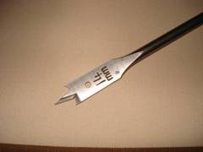 picture 12

For several reasons it is better to postpone the fixing of the chimney until the end.

MAKING THE CHIMNEY

If you want to make a chimney as shown on picture 10, first choose a copper pipe that is in harmony with the size of the wooden shoe. To give you an idea, for shoe
size 7.5” my chimney ( picture 10 ) is made of a ½” (12 mm) O.D. size copper pipe and a length of about 3” ( 7,5 cm) .
If you want to make the top of the pipe like a trumpet cup, buy a piece of pipe of about least 20” (50 cm). Anneal the material, but only at the far end. Take an old drill of about ¾ of the inner diameter of the pipe. If the rear end of the drill is rather sharp, the pipe will be damaged during the bending. To prevent this, grind the drill until its end is smoothly rounded.

Procedure:
Adjust the drill firmly upside down in a vice, so that only ½” (1,27 cm) of the rear end will protrude. Hold the pipe at almost ¼ ‘’ over the top of the drill and push or pull the pipe forcefully until the material at the top is bent at an angle of about 45 degrees.

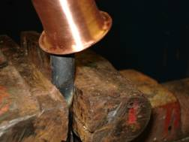 picture 13

Now you will understand why I prefer to start with a long pipe. Repeat this, turning around the pipe a 10-20 degrees each time. After a complete turn, anneal again and repeat the bending procedure. Depending on the size of the pipe and how pronounced you want to make the cup, more annealing will be necessary of course. At the end, the over-all form of the cup may be reasonable, but still a bit irregular. This can be corrected by repeating the bending locally and if necessary with the help of a pair of tongs. Now the chimney has to be fashioned. The most efficient method is to grind it on a tape-grinder mounted upside down using a fine grid. Further finishing can be achieved with a Scotch Brite pad.

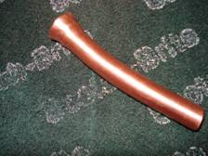 picture 14

Now the final length of the chimney can be cut. You can do this with a small saw, but more professionally with a special cutter such as used by plumbers.

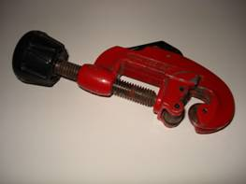 picture 15
THE ALCOHOL BURNER

Using an alcohol burner asks for certain precautions. If the alcohol reservoir is positioned inside the hull, given the small volume of the fireplace, the temperature of the alcohol can rise quickly and steam-shoe can catch fire. An effective way to prevent this is to position the reservoir under the hull.

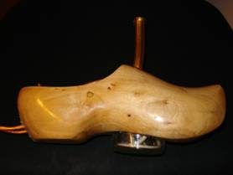 picture 16

By doing so, a constant cooling of the fuel is guaranteed. Other advantages are: the reservoir adds to the stability of the vessel, the layout of the fireplace can be more neatly arranged and most importantly, the position of the burner opposite the coil is standardised.

Browse around in different shops for a suitable reservoir. We need one that: a/ fits with the dimensions of our hull, b/ is rather shallow, c/ can contain enough fuel, d/ has a reservoir that is transparent so that the fuel content can be checked any moment. Look for a pot of clear glass with a tin screw cap. The fuel check is especially easy when blue spirit is used. Damage (burning) of the wicks as a result of an empty fuel tank can easily be prevented by this. Very suited for the larger vessels
(nos. 3 and 4) are glass shoe-cream pots for instance. Diameter about 2.4” (6 cm). For the smaller boats (nos. 1 and 2) you will find certainly something in a delicatessen store.

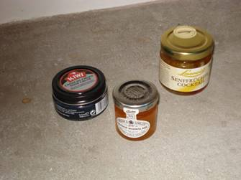 picture 17
.

The next thing to do is drill a hole in the bottom of the hull. The centre of the hole has to be on a line parallel to the longitudinal axis of the shoe and trough
the centre of the hole of the chimney. As a rule, 1/3 of the cap has to be positioned right under this centre and the rest in front of it.. In transversal direction the cap has to be positioned in the middle of the bottom. The hole in the bottom is made with a drill as shown in picture 18.

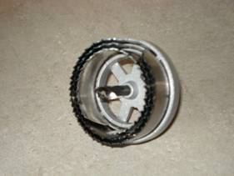 picture 18

Choose a size that leaves some space for the glue.

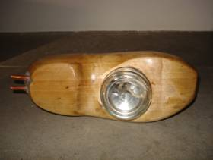 picture 19: the reservoir in situ.

THE WICK-HOLDERS.

The wick-holders are made from about 1 1/3”(8,5 mm) long tubes .
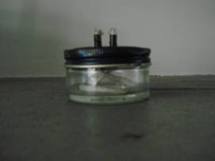 picture 20

They have to be soldered about half way inside the cap. (picture 20). Depending on the shape of the bottom side sole it is necessary to position the cap eccentricly
underneath the coil (picture11), in the direction of the stern. This means that the wick-holders too, have to be placed eccentricly, at the most backwards part of the cap in order to position the wicks right under the lowest spot of the coil. As a rule, tubing for the coil of 4mm O.D. can be used for the wick-holders.
Depending on the I.D. of the tubes and the number of turns of the coil, one or two holes for the wick-holders have to be placed. For drilling them at the right places, fix the engine provisionally, by bending a loop of stiff iron wire around the coil, just in the middle. Pull both ends of the wire tightly trough the chimney hole and bend one end to port and one to starboard, if necessary with a pair of tongs. Hold the engine in position by hand until it is fixed by the tension of the wire.
Also the cap has to be placed provisionally (with poster buddies).
Following the next indications, now you can determine the right places for the wick-holders.

In transversal direction: As said before, in case of 5 turns or more, two wick-holders are preferrable. They have to be placed so that they divide the length of the coil roughly in three equal parts. For engines with three or fewer turns, one wick in the middle is sufficient.

In vertical direction: the length of the protruding part of the wick will be about 1/17” (1,5 mm) The distance from the wick to the lowest part of coil has to be about 1/2 “ (12,7mm).

In longitudinal direction: place the wick-holders perpendicular under the lowest part of the coil.

For the boats that are shorter than 8.6” there is only room for engines made from thin pipes (about 1/13”- 1/8” I.D. (2-3 mm). Depending on the brand, this corresponds to an the O.D. of about 1 ½ mm more. To power these boats, engines with a coil I.D. of 2/5”-½” ( 10- 12.5 mm) generally perform satisfactory, but who likes to experiment can try more turns as long as there is enough space.

Once the position of the wick-holders is determined, mark them with a pencil or a sharp pin.

Now remove the cap and punch dentations with a centre-point on the spots where you want to drill the holes. Start with a small size (1/12”) drill. After the wick-holders have been soldered, check once again if they are properly positioned. Reposition the cap provisional again. The check is facilitated by sticking matches through the wick-holders.

Besides, for easy adjustment, factory-made wicks are preferable. These are available in maritime shops and sometimes in shops where cosy lighting is sold. Bear in mind that after some time of being immersed with blue spirit, these wicks will expand a bit. By this, the flow of the fuel to the free end of the wicks can be choked, reducing the heat. Therefore, choose wicks that do not fit too tightly.

THE FILLING PIPE

Besides the wick-holders, a longer pipe has to be soldered on the cap. This pipe is meant to fill (or to empty) the alcohol reservoir without removing it from the hull. Why this is not a just a gadget, but a very useful feature, will be explained later. As it will be necessary to remove all the remaining alcohol after sailing, it is important that the connection of the pipe is flush with the bottom of the cap. For the configuration of the pipe see picture 21.

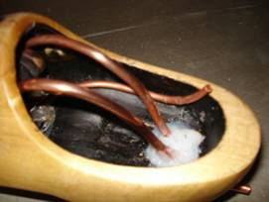 picture 21

This is the right moment to bear in mind the precise relation to the bottom and the inner wall of the shoe. Later, when gluing the cap, this will be very helpful in determining the right position.

MOUNTING THE ALCOHOL- RESERVOIR

The cap has to be positioned as much as possible in a horizontal plane and in line with the sole of the shoe. At the same time the rim of the cap has to be embedded all around into the sole in order to ensure a strong and watertight connection. Sometimes this is impossible to achieve because the sole has to much slope. If so, grind the sole until a more or less horizontal plane is attained. A very efficient tool is the so called Power File (Black& Decker BO 292E). But even after this correction it is not easy to get a reliable connection. To facilitate this, follow the next indications:

Take a thin plate of copper (about 1/30” (0,8 mm)) and cut a flat ring. The inside diameter of the ring has to be about 2/5” (10 mm.) smaller than the diameter of the rim of the cap and an outside diameter of the ring has to be 2/3” (17 mm) larger. Place the ring in a centric position upon the cap and scratch with a sharp pin the inner circumference on the cap Sandpaper the cap in this area free of paint. Solder the inside border of the ring on the cap all around. Stop occasionally to prevent damage to the packing at the inside of the cap caused by the heat. Replace the cap inside the shoe. Screw the reservoir under it to facilitate finding the right position. After this is found, press softly the overhang of the ring down against the sole. A close touch all around is not required. As soon as the position for the cap is stable, the adaptation can be stopped.

Remove the cap again and fill the corner between the rim and the overhang of the ring generously with silicone. Eventually, apply some silicone on the shoe on the corresponding places as well. Try to push some silicone in the cleft between the ring and the cap as well, but avoid disturbing the shape of the overhang just attained..
The cap is brought in the desired position (look at the filling pipe!) and softly pressed against the sole until no more silicone protrudes. While keeping the cap in position, carefully remove the reservoir. Remove the surplus of silicone. Now wait until the silicone is completely hardened. Once again make sure that no silicone gel is left inside the crew cap.

Warning: if you are not quite sure about the position of the cap, maybe you are inclined to check this by screwing the reservoir once again under it. Unless you are absolute sure about a substantial dislocation, don’t! Even if the glass is removed immediately after partial hardening of the silicone, the position of the cap will be easily disturbed again. Waiting until the silicone is completely hardened will inevitable lead to a disaster; the removal of reservoir will be absolutely impossible.

MOUNTING THE ENGINE

As soon as the silicone is hardened, the engine has to be mounted.
The global configuration of the pipes behind the coil we have already discussed in chapter “Instructions for Making a Coil Engine”. Now we have to adapt this configuration more precise to the hull. Keep a few things in mind:
Firstly: From the coil, the pipes have to incline slowly upwards at about 1 or 2” depending on the diameter and the size of the coil. From there they have to decline to the deepest part of the hull.
Secondly: When resistance is felt against bending, anneal the pipes again!
Thirdly: the parts of the pipes leaving the vessel at the stern have to incline slightly upwards.
Fourthly: Avoid sharp angles.

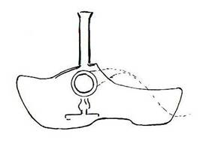 picture 22

Before the engine can be given the desired shape, gangways for the pipes have to be drilled in the stern, at or near the deepest point of the hull.
Don’t be afraid to drill too generously because it might look bad. When the vessel is launched, these spots are under water and hardly visible, especially when transparent silicone is used. Make the gangways so wide that the engine can be shoved in and out without any bending of the pipes.

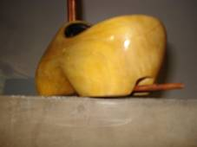 picture 23

Don’t be tempted to make the pipes behind the stern the stern too short for aesthetic reasons. Though the optimum ratio between the coil and the pipes is not known, my impression is that you can better leave them a bit too long than make them too short.

THE HEAT SHIELD

Before the engine is mounted in the hull, a heat shield has to be installed. This can be made from a tin can. The material can be adapted by pressing a piece of tin in the estimated form against the inside of the roof of the instep and then cut in shape with a pair of scissors. To make the adaptation easier, soften the material by heating it until red and letting it cool down slowly. Now hold the shield with one hand at the desired place and make a perforation in the tin in the middle of the chimney hole. Enlarge the perforation a bit and make a few radial cuts that correspond with the I.D. of the chimney hole.. Press the shield upwards to fold it in the hole. This ensures positioning the heat shield in the right place, it can now be fixed with a few drawing-pins.

Now is the moment for the final adjustment of the engine. First, the coil must be brought in position, with an iron wire, just as you did before, but now with the pipes in the gangways. Keep the pipes near the bottom of the gangways. You may have to take precautions against dislocation by placing a weight on the extending parts of the pipes behind the stern. Apply some silicone around the tubes and fill only the middle of the gangways. Wait until the paste is hardened. Fill the gangway at both ends flushly with silicone on both sides of the shoe with silicone. As soon as the material is no longer sticky it can be finished with a wet or lightly oiled finger. Not until complete hardening, the iron wire can be removed.

Now it is time to finish the job by mounting the chimney. The question is how. As the chimney will become very hot, I do not know any ideal material to fix it. After trying a lot of materials, I prefer Lock Bond or Lock Tight. (used to secure screws and nuts).

FIRST TRIAL.

PREPARATIONS:
a/ Start with wicks protruding not more than 1/24” (1 mm. ) from the wick-holders. Later, after some experience, you can judge if this length has to be adapted.
b/ Fill your bath or tub with cold tap water.
c/ Take a small syringe and inject water through one end of the pipes until it escapes through the other.
d/ Keep the steam-shoe with its nose down and shake thoroughly.
e/ Turn the rear down after a few minutes and let the water escape.
f/ Fill the alcohol reservoir through the filling canal. I use a 10 cc syringe with a wide needle. Bend the needle for convenience. (picture 24)
Repeat injecting as often as needed, but avoid filling the reservoir completely! It is not necessary to close the open end of the filling pipe. If the boat has not sailed for a while, wait at least 2 or 3 minutes before lighting. The wick must be well saturated with alcohol, otherwise they will be damaged.

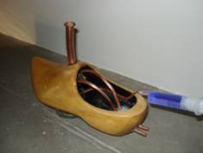 picture 24

AFTER LAUNCHING

1/ Within 30 seconds the first air bubbles will escape trough the nozzles and soon after that the water behind them will begin to vibrate. After about 1-3 minutes the boat will start sailing. Don’t be impatient when your vessel is a slow starter. Usually the speed will increase soon. It will take at least 45 minutes of undisturbed running before the performance has reached its top.
2/ Occasionally the sequence as described here does not occur and the engine is not giving any signs of life. The therapy is simple. Fill a syringe with 1-2 cc. water, stabilise the vessel in the water with one hand, insert the needle as far as possible in one of the pipes and inject quickly. Bend the needle at its base about 45 degrees for convenience. See picture 25.

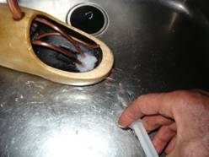 picture 25

Stop injecting immediately at the moment your action is followed by a powerful steam blast. The engine will immediately start pulsating vigorously..
If no steam blast appears, you have been too impatient. The engine was still too cold. Wait and repeat if necessary.

3/ If after some time the performance is decreasing, lift the vessel from the water, let any possible excess of water escape from the pipes and replace it. If you are lucky, this measure is rewarded by a quick improvement. If so, this may be an indication to incline the pipes some more at the rear.

4/ If this is your first trial with a specific wick adjustment, feel the declining parts of the pipes with your fingers from time to time. If these parts are hot, this indicates you have to adjust the burner by pressing the wicks downwards little bit. If they are cold, try what happens when you raise the wicks a bit. Perhaps this improves the performance. But too much heat will give adverse results.

5/ Never adjust the wicks with your fingers. Only with a sharp pair of pincers this can be done with precision.

6/ Regular inspection of the fuel level: The main advantage of the glass reservoir is the easy inspection of the fuel content. This way the burning down of the wicks can be prevented. Adjustment of the wicks will seldom be necessary.

7/ As indicated above, by regular opening and closing of the glass reservoir leakage can easily occur. Try plumbers tape. If it does not work, don’t worry. As soon as you have some experience with the adjustment of the wicks and of course the regular inspection control of the fuel, simply glue the glass in the bottom of the shoe with silicone.

8/ After sailing your steamshoe, empty your fuel tank completely. Blue spirit contains15 % water. If you fail to empty the tank, the alcohol will evaporate until only some water will remain, making it very difficult to light the wicks next time.

9/ Never touch the chimney of a running vessel, except during the first trial, to check my warning.

10/ The gluing of the alcohol burner and the engine in the shoe is a messy job. If you want to varnish the hull once more at the end, it will be impossible to do it neatly. Sandpapering the surface is not a solution unless followed by a treatment with silicone remover.

12/ Hints 1-14 will often be successful, but not always. Pop-pop engines have a will of their own.
Don’t be disappointed. After some experience you will find better solutions then described here. Sail away!

 picture 26
the authors design for a new coat of arms

* Pop Pop Pages, www. Google, site “Slater Harrison”

** On www. Google.nl you will find under “klompen” several commercial sites. My favourite is Klompenmakerij Traas. It does not matter whether you order 1 pair of shoes or 500, Mr. Traas will not be flustered, and will send you what you ordered within 3 weeks. Ask for the tourist model (in Dutch: spitsneus’), already varnished, but without the usual decorations. (in Dutch: “in de blanke lak, zonder versiering”). On the site you will find the prices. If necessary you can call him. His telephone number. is on the site.
You can place the order inches, but I think it is safer to do it in centimeters. One inch is 2,54 cm.
You might even consider ordering another pair for walking!

*** Available sizes of wooden shoes: Very small sizes are : 6,8,10 and 12 cm. ( ¼”- ½ ‘) These shoes are not made for walking, but are sold as souvenirs. In my opinion they are too small for a real steam-shoe.
The bigger- and better sizes are in the range of 16-33 cm. (6”-13” ). My experience stops at 27 cm. Attention! By these sizes , the shoemaker indicates
the length inside the shoe. As a rule of dumb, the outside-length is generally 2-5 cm (ca. 1-2 inches) larger than the inside length-size used by shoemakers .

