Building a diaphragm pop-pop engine

What follows is an example of how to build a diaphragm pop-pop engine. There are thousands ways to build such an engine, and an infinite number of possibilities for size and materials. It’s up to you now, depending on means and circumstances.

Components:
- A small copper sheet (here 65x50 about 1mm thick recovered from an old plumbing pipe)
- A piece of thin metal sheet (here new brass of 5/100mm thickness). A piece of metal from a can could fit. An efficient and cheap alternative is the use of the bottom of an aluminum food container (Lasagna, rice cake…)
Note: My first engines were not emitting the pop-pop sound due to a too thick and rigid diaphragm (i.e. brass15/100mm).
- A pipe (here brass of 8x1 improperly called 6-8)
Tools:
- Matrix and puncher (we will tell you further how to build them by means of pieces of wood and metal, using a few screws and tools)
- Pair of pliers, hammer, drilling machine and 8mm drill.
- Metal saw
- File
- Sand paper or steel wool
- Small welding torch. If you don’t have such a torch, a candle could suffice.
Additional tools such as a small pair of shears, a pipe cutter, a vice…could be useful, but they are not really needed.

Consumables:
- Soft welding metal
- Pickle paste
- Silicone filler

Matrix and puncher:
The ideal is to have a friend who owns a grinding machine. We all dream to meet such a friend, but alas…
Other alternative: welding small steel pieces together. You will object that not everybody has got a welding machine…
Therefore, we will use another way. Take a piece of relatively hard wood which doesn’t chop too easily. Here, we used a left over of iroko, but a piece of thick plywood could have been suitable. On this support, fix some small steel pieces by means of screws so as to materialize a rectangle. Ours is 42x27. If the steel pieces you use are less than 3 mm thick, dig a little in the wood by means of a chisel. The matrix is finished.
For the puncher, you just have to cut a small rectangle (40x25 in our example) in a steel sheet leftover of 4 to 5 mm thickness. Then, round off angles and edges by means of a file. You should get something looking approximately as this:
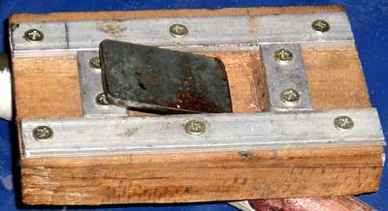
Here, the puncher in inclined to show that it is simply a piece of steel sheet.

Copper sheet:
The easiest way is to recover a piece of pipe (water distribution, central heating, gas…). It is important to use annealed copper, i.e. it must have followed a thermal treatment in order to softer (malleable). If you reuse a pipe that was bended or brazed, it is very likely soft enough. If not, heat it until it becomes red and then, let it cool down, preferably slowly.
Cut the pipe along a generatrix (as shown on the picture).
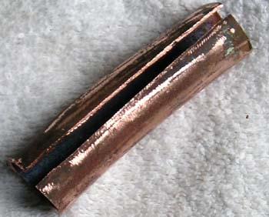
Widen the opening by means of two screw drivers, then by means of pliers. If the pipe has been annealed properly, this should be very easy. Put the unrolled pipe on a flat support and hammer it lightly to flatten it. Here is the result.
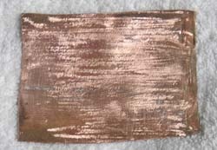
The outline is not quite beautiful, and very likely the dimension is not the final requested one. Therefore, use the metal saw or the shears to cut a suitable rectangle. Then cut the angles at 45 degrees. You will understand why later.
To punch in this piece of copper sheet, put the matrix on a strong and heavy support (workbench, IPN, rail…). Put the copper sheet on it, and put the puncher on the top, checking visually that it is centered with the matrix. A big hammer shot and the sheet must start to be punched in. Then, the puncher centers itself automatically. Go on hammering until you get the desired depth (2 to 3 mm).
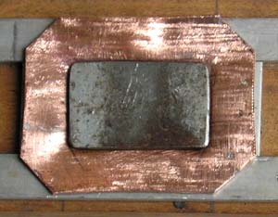

Then, with pliers or vice, fold the sides, at approximately 90 degrees in a first step. And, with the drilling machine, drill a hole to introduce the pipe (or the pipes. When there are two pipes, filling the engine with water is easier once the engine is finished).
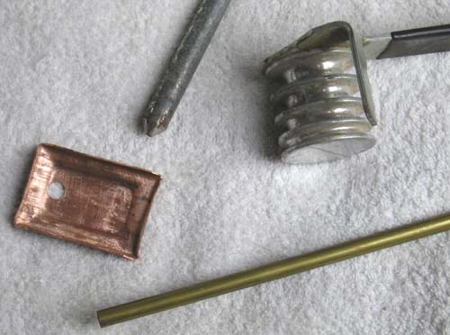
Note: I used to punch a little bit the copper sheet around the hole by means of a very coarse puncher visible on the top of the picture. It is a piece of round steel bar of which the extremity has been formed as a cone by means of a grinding machine. I put the copper part on a piece of soft wood, and with the puncher I deform it so as to put the pipe end not too close to the future diaphragm. This is not a must, but it could help.

Pipe:
To bend the pipe, if it is made of copper or brass, you must anneal it first. (Proceed as above). Then, with a little bending tool it is a child game. If you don’t have such a tool, a small pulley could be used to get the same result. If such a pulley is not immediately available, take a piece of wood (of about 15mm thick) and drill a hole of the same diameter as the external one of the pipe. Round off one side with a cylindrical wood file. Insert the pipe. Bend it slightly with this tool. Push it a few millimeters and bend it again. Repeat this until you reach the desired shape. The final result should look like this:
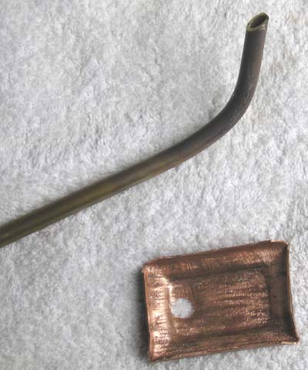

It remains to connect the parts together.
For semi pros (!) everything can be soft welded, but for the diaphragm it is sometimes difficult because when heating it to weld one end the other end becomes loose…
The easiest way is first to weld the pipe on the copper part, and then to fix mechanically the diaphragm by pinching, the tightness being ensured by means of some silicone filler. (Advantage of such filler: it works with any material). Hence, start with soft welding and you should get something like this:
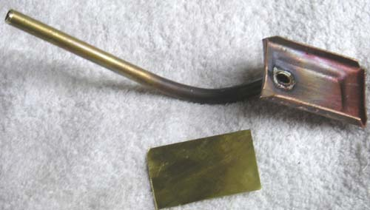

Then lay a very thin filler string along the angles of the folded sides, and put the diaphragm above. Fold completely the sides by means of pliers or vice to pinch the diaphragm all around.
Wait a few hours for filler drying.
Engine is ready.
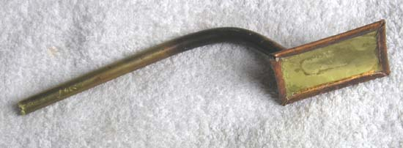
After that, all the fantasies are allowed to fit this kind of engine on a floating hull…
