Meeting with Professor Le Bot. Dec.5, 2006-12-06

We had a very interesting meeting. Six hours without any dead time. Pr Le Bot knows so much and has always something to say or to show. 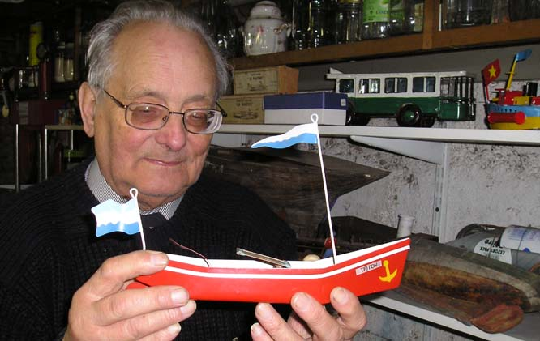
This is a picture of Pr Le Bot showing a Rose boat with a very thin evaporator. Is it (the thinness) the secret of these boats? I took this picture in the garage. The house is a museum. Even the garage is a museum. Behind Pr Le Bot you can see very old wooden hulls. On the right bottom is a Jeff’s steam car. On the shelf just above is a very colourful boat with additional floats on each side because it was originally too heavy to sail. In front of the bus the boxes contain old pop-pop boats…
Below is a picture of the battle ship Jeanne d’Arc. The ship is approx 80cm long. Inside there are 3 pop-pop engines of diaphragm type. The three port nozzles are shown by the arrows.
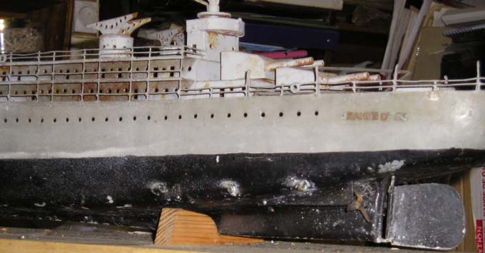
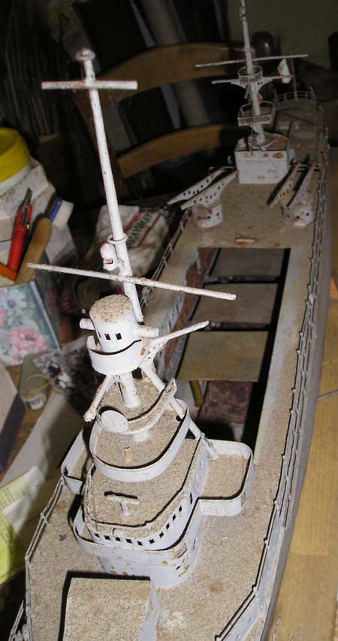
There you can see the upper part of the three engines. On each one, the diaphragm is folded around the evaporator. Thus, the diaphragm area is maximal. We had not enough time to light the boilers. According to Pr Le Bot, the sound of the three engines running simultaneously is impressive and the ship is sailing relatively fast.
This is the last acquisition of Pr Le Bot. A pop-pop boat built in Burma.
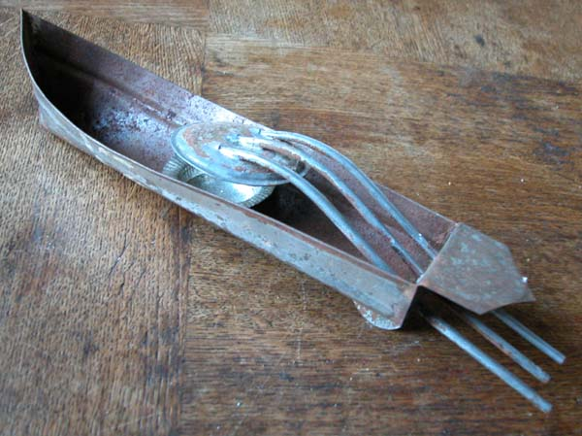
It is fitted with three pipes. This is not new. But what is unusual is the fact the diaphragm is on the bottom side.
The design of the hull is also interesting. It is a single tin sheet that is only folded with only 3 small soldered joints (bow and transom on each side).
No need of special tool to build such a hull.

Pr Le Bot showed me some wooden models he used to build his own tin hulls. When I have time I will try to use the same method and explain how to proceed.

We had a long discussion concerning the performances that are better when there is some air (or other gas) inside the evaporator. We couldn’t explain why. After a while he remembered and showed me a report from John Gwynn where it was noted at least two things which confirm the results of my last experiments: 1°) the thrust is bigger after 20 minutes. 2°) the thrust increases by 11 to 14% when there is air inside. The figures depend on the engine, but the trend is the same.

Pr le Bot has so many files that we had no time to look at the documents. I expect to get copies of some interesting reports when he has time… The main problem is his availability. On one side he is very busy, and on the other side he his handicapped by a bad vision. For instance he needs a magnifier to work with his computer. He expects to have eye surgery in January. I whish it will be a success.

