Efficiency of a pop-pop engine.

Our first estimate was done in early 2005 with a small Indian boat. The first following lines are a copy of what was written at that time.

Small Indian boat.
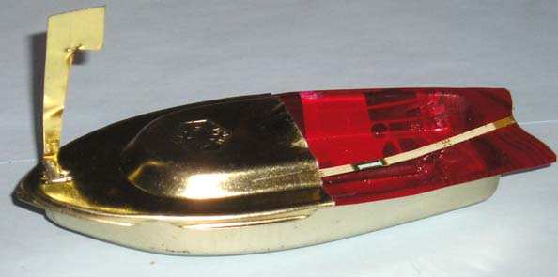
Because of the propulsion principle, the boat being sailing at the speed V, the output of the waterjet needs to be at least once par cycle faster than V.. v_{max}>V
Let’s suppose the flow perfectly sinusoidal. Every point of the liquid snake moves by $d=\text{aSIN}ωt=\text{aSIN}2π\text{Ft}$ F being the frequency of the cycle. Derivation of this equation gives the speed of the water inside the pipe. $v=2π\text{FaCOS}2π\text{Ft}$
v_{max}=2πFa>V. With F=8Hz and V=0.15m/s we get a>3,2.10⁻³m a>3,2mm
a being the half amplitude of the displacement, the total stroke is more than 6.4mm.

These last three data allow to compute the global efficiency which is the ratio between the released mechanical power (drag force multiplied by speed) and the supplied heating power which is the one of the candle: $r=\frac{T×V}{F}$ For this application $r=\frac{0\text{.}\text{002}×0\text{.}\text{15}}{\text{28}}=0\text{.}\text{0011}\text{\%}$. It’s pathetic! As the measures were not performed as laboratory ones, the relative uncertainty on some of them is big; but they are only three. Assuming we were very bad or very unlucky so that on the three of them we made an error in the same way, and from single to double (it is nevertheless enormous to do that), the efficiency would become 0.0088%. We can accept that during the “endurance” test the flame of the candle was not as big as it could have been, and if we accept a worse condition 10 times less, the best result could only reach 0.088%. It is to be compared to the 35% of a classic propulsion (50% for the engine and 70% for the propeller). This is still very very bad and justifies that there has been no industrial application of the pop-pop engine.

Comparison with a mechanical propulsion (spring+propeller) on toys of the same size.
1°) Spring. To wind up the spring requires about 10 turns of the key with a torque of 200mNm (0.2Nm). Corresponding energy: 0.2*2*p*10=12.6Joules. It is minute. This engine propels the boat for approx 12.6 seconds (to simplify). Therefore, the power is 1W. Taking into account the mechanical efficiency and the one of the propeller the delivered power is smaller. Let’s say 0.5W.
2°) Candle. Though it is not obvious, the power and the energy delivered by a candle are relatively big. A small birthday candle (mass: 1 gram) delivers approx 35W as heat, and it takes 10 minutes to burn. Corresponding energy: 21kJ. With 2 grams burnt in 5 minutes (data from Professor Le Bot) it means 42kJ and 140W.
3°) Efficiency. The efficiency of such a small toy is likely about 10 times less than the one of a big ship; i.e. approx 3.5%. Professor Le Bot measured similar thrusts with mechanical propulsion (1W 3.10⁻²N) and pop-pop propulsion (140W 1.8.10⁻²N). It means a ratio of 233 in favor of the mechanical propulsion. Dividing 3.5% by 233 gives 0.015% and it can be checked that it is lower than 0.088% calculated before by excess. This consolidates our measures and computations.

Later experiments.
Specific experiments ran in 2006 with an electric heating source allowed to improve the knowledge of the efficiency and to improve the efficiency in some circumstances. A pop-pop engine can sustain any type of heater. The electric heater is reserved to the test bench. It allows to know and to control the power consumption.
There are so many different pop-pop engines (with or without diaphragm, with one or two pipes, sometimes three, and with various pipe diameters and lengths, with or without nozzle…) that we are not going to examine all of them. We will look at the efficiency of two of our more powerful engines, a coil engine and a diaphragm one.
The purpose of this document is an efficiency estimate. Therefore, we must say that it is not necessarily the more powerful engine which is the best for efficiency. However, according to the examples we have looked at, for a given engine the efficiency increases with the power. We will give an example.
The figures used hereafter correspond to the mean values during rather stable conditions for several tens of seconds. For very short durations we got sometimes quite bigger figures (almost double) but due to the thermal inertia of various components (engine and heating device) using these figures would be cheating.

Diaphragm engine.
Constitution: drum (evaporator) of which the lower wall made of copper has an internal area of 12.5 cm2 and a volume of 1 cm3. Pipe made of brass with internal diameter 6mm and thickness 1mm. Length: 330mm. Pipe outlet slightly grooved on the outside.
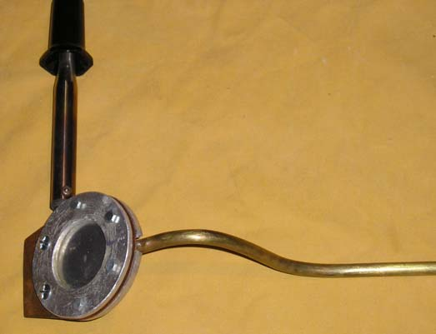
On this picture the soldering iron visible on the left has been modified. It is fixed to the steam drum.
At the bottom, towards the right side is the single pipe.

During the tests the engine was packed inside an isolating material to limit the heat losses in air.
This engine exerted a thrust of 30mN for an electrical consumption of 100W. The same thrust was got with a grooved nozzle of the same diameter when using a permanent flow of 24.5 cm³/s (cf. document "Thrust measuring test bench").
By dividing the flow by the nozzle area we get the speed : 0.87m/s. And the power is got by applying the formulae $P=\frac{1}{2}{ρQ}_{v}V^{2}$ which in this case gives 9.2mW. The efficiency is the ratio of this power by the heating one; i.e. the efficiency is roughly 0.1% (taking into account some dissipation in the air).
Coil engine.
Constitution: engine made of copper 6x1 (i.e. internal diameter 4mm) with 4 turns around a diameter 12mm. Length of each pipe out of the coil: approx. 190mm. Strait cut.
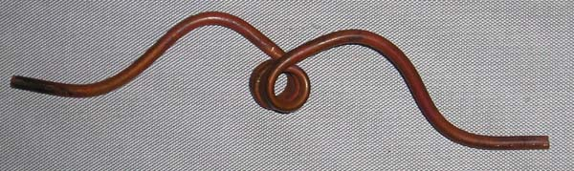
As it can be seen on the picture, the pipes are on both sides of the hot section. This is a special engine for test bench use only.

This engine delivered a thrust of 2x17mN for an electrical consumption of 50W.
The same thrust was got with a nozzle of the same diameter when using a permanent flow of 14cm³/s; which corresponds to a velocity of 1.11m/s and a power of 5.7mW; i.e. (when multiplying by two because there are two nozzles on this engine) an efficiency of 0.023% rounded to 0.03% to take into account the losses in air.

For information, this engine delivered 2x12mN for 25W. The same nozzle exerts 12mN for a permanent flow of 9cm3/s; which corresponds to a velocity of 0.72m/s and to a power of 2,3mW; i.e. an efficiency of roughly 0.02%.
This efficiency could look bad compared to the previous one because a the denominator the consumed power is half the previous one, but a the numerator the flow and the velocity (which intervenes as square) are each one reduced by almost one third.

Conclusion :
It is confirmed that the efficiency of pop-pop engines is pathetic. That is the reason why there were no industrial applications, and very likely there will never be one.

This conclusion doesn’t alter the fascinating aspect of this amazing engine without any moving part.

