Some pictures of realizations and experiments
1°) Measurement of the power of a candle.
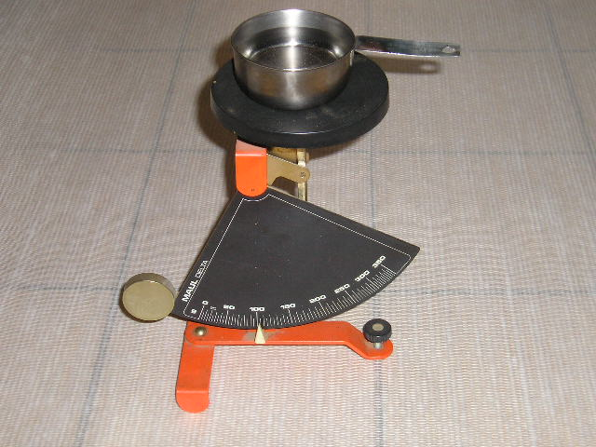
Scales to get weight of container and water (separately)

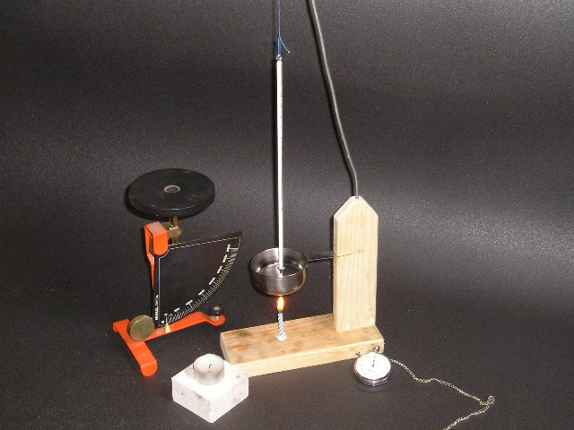
Thermometer
Chronometer

2°) First realization of a pop-pop engine
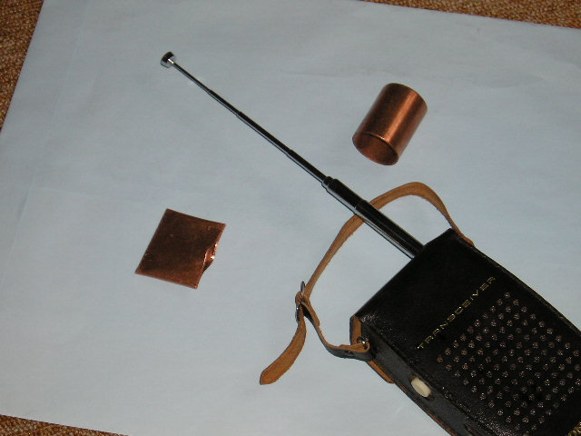
What shall become a drum
Drum after fabrication
Future pipes

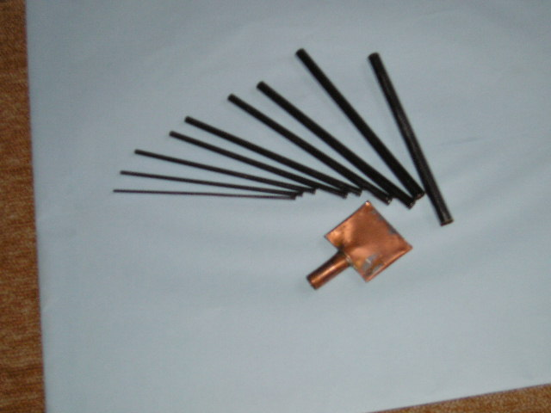
9 pipes got from the antenna of the walkie-talkie.
3°) Application on a catamaran
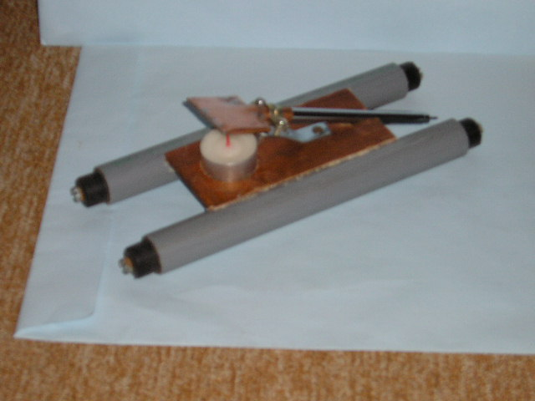
4°) Some engines and syringes (to fill engines with water) + 2 old membranes.
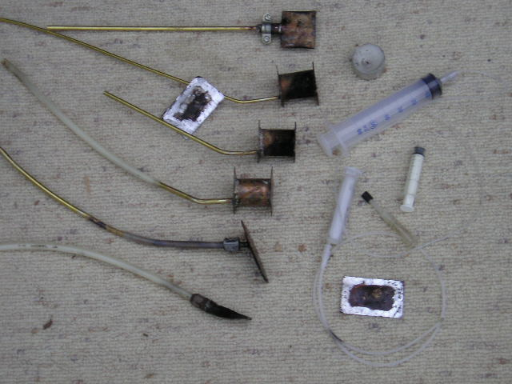
5°) Indian boat + 18 engines, among which 3 with identical big drums and 9 with small identical flat drums (+ 2 syringes to fill most of the engines… because they have only one pipe). The front left engine is the only one with a diaphragm.
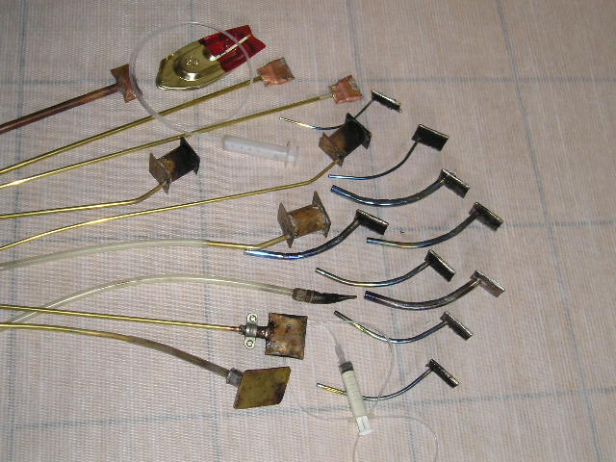

6°) Measuring tool for the bollard pull thrust.
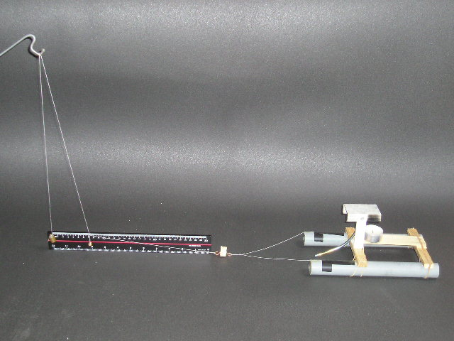
Plumb line
Counterweight
(2g)
Float with a hook
Engine being tested
Graduated rule to measure the longitudinal displacement of the counterweight
Catamaran
Note : for the picture, the link between the counterweight and the float has been shortened and everything has been taken out of water.
The scale is given by the triple decimeter rule (approx 12”).

